**CHAPTER III**

**DESIGN PROJECT DEPLOYMENT AND PRESENTATION**

3.1 DESIGN PROJECT HARDWARE

The design project uses a master/slave model. The Arduino (Slave) is connected to the Raspberry Pi (Master) through micro USB cable. The Arduino is connected to the main components such as the coin slot, thermal printer and servo motors.

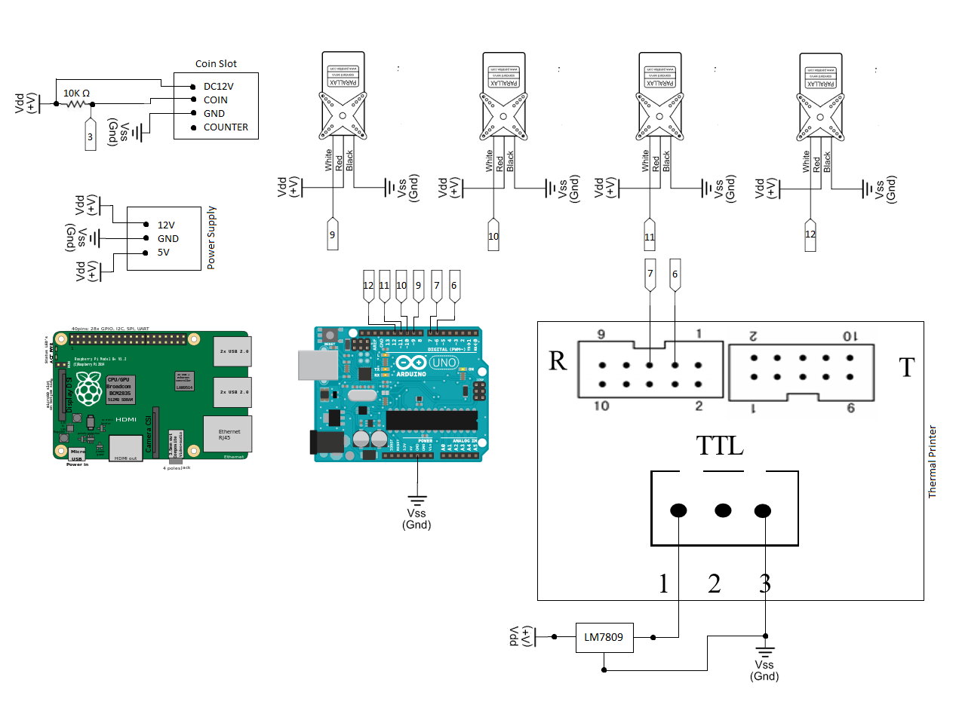

*Figure 3.1.1 Circuit Design*

3.2 DESIGN PROJECT SOFTWARE

A software is required for the hardware to operate. The system runs on GNU/Linux operating system, LAMP is also installed for the main software. Third party software are also installed such as python, butterfly and phpmyadmin. There are two software programmed for the system to be functional. One is the firmware for the Arduino (microcontroller), which is responsible for controlling the modules as its name implies. Second is the web application for the Raspberry Pi (Single Board Computer), which has more processing power than the microcontroller is responsible for processing data and the main operations for the system.

<?php

include("config.php");

//store product information on variables

$slot = $_POST['slot'];

$price = $_POST['price'];

$product_id = $_POST['product_id'];

//insert a new transaction on the database

$mysqli->query("INSERT INTO transactions (transaction_id) VALUES('')");

$results = $mysqli->query("SELECT MAX(transaction_id) AS transaction FROM transactions");

$obj = $results->fetch_object();

//echo $obj->transaction; //debug

$mysqli->query("INSERT INTO orders VALUES('','{$product_id}','1','{$obj->transaction}')");

//insert a new transaction on the database

$mysqli->query("INSERT INTO notifications (notification) VALUES('New Transaction: {$obj->transaction}')");

//update the income on the database

$results = $mysqli->query("UPDATE income SET income=income+{$price} WHERE income_id='1'");

//insert a new notification on the database

$results = $mysqli->query("SELECT * FROM income WHERE income_id='1'");

$obj = $results->fetch_object();

$mysqli->query("INSERT INTO notifications (notification) VALUES('Updating Income: &#8369; {$obj->income}.00')");

//update the stocks in the database

$results = $mysqli->query("UPDATE products SET stock=stock-1 WHERE product_id='$product_id'");

//insert a notification on the database

$results = $mysqli->query("SELECT * FROM products WHERE product_id='{$product_id}'");

$obj = $results->fetch_object();

$mysqli->query("INSERT INTO notifications (notification) VALUES('Updating Stock: {$obj->stock}')");

//subtract the price of the medicine on the credit

while($price != 0){

exec('echo e > /dev/ttyUSB0');

$price--;

}

//notification is in index.php

//insert a new notification on the database

$results = $mysqli->query("SELECT * FROM products WHERE product_id='{$product_id}'");

$obj = $results->fetch_object();

$mysqli->query("INSERT INTO notifications (notification) VALUES('Dispensing Item: {$obj->brand_name}')");

//dispense the medicine

sleep(2);

exec('echo '.$slot.' > /dev/ttyUSB0');

//insert a new notification on the database

$mysqli->query("INSERT INTO notifications (notification) VALUES('Printing Receipt: Ok')");

//print receipt

exec('echo pprinting > /dev/ttyUSB0');

//check stock of the medicine

$results = $mysqli->query("SELECT * FROM settings WHERE setting='stocks_critical_level'");

$obj = $results->fetch_object();

$critical_level = $obj->value;

$results = $mysqli->query("SELECT * FROM products WHERE product_id='{$product_id}'");

$obj = $results->fetch_object();

if($obj->stock <= $critical_level){

//notification

$mysqli->query("INSERT INTO notifications (notification) VALUES('Checking Stock: Low')");

$mysqli->query("INSERT INTO notifications (notification) VALUES('Alert: Sending SMS')");

//send sms notification

header("Location:http://192.168.2.5:9090/sendsms?phone=0906*******&text=low stock&password=");

}else{

//notification

$mysqli->query("INSERT INTO notifications (notification) VALUES('Checking Stock: Ok')");

}

?>

/*

* Project: Vendo Firmware

* Version: 1.0

* Author: Leo Neil Reed

*

* Command Reference

* q - return credit

* w - add credit

* e - remove credit

* r - reset credit

* 1 – slot 1

* 2 – slot 2

* 3 – slot 3

* 4 – slot 4

* a – dispense 1 peso

* s – dispense 5 peso

* d – refund

* f – print receipt

*/

#include <Servo.h>

/*

* Variables

*/

volatile int credit = 0;

Servo myservo1;

/*

* Setup Function

*/

void setup() {

Serial.begin(9600);

attachInterrupt(digitalPinToInterrupt(3), credit_inc, RISING); //coin -> pin3

myservo1.attach(9);

}

/*

* Main Loop

*/

void loop() {

if(Serial.available()){

char cmd = Serial.read();

if(cmd == 'q'){

credit_ret();

}else if(cmd == 'w'){

credit_inc();

}else if(cmd == 'e'){

credit_dec();

}else if(cmd == 'r'){

credit_res();

}else if(cmd == '1'){

dispense(cmd);

}

}

}

/*

* Credit Functions

*/

int credit_ret(){

Serial.print(credit);

Serial.print("\r");

}

void credit_inc(){

credit++;

}

void credit_dec(){

credit--;

}

void credit_res(){

credit=0;

}

/*

* Dispense

*/

void dispense(int slot){

myservo1.write(0);

delay(1000);

myservo1.write(90);

delay(3000);

myservo1.write(180);

delay(1000);

myservo1.write(90);

}

3.3 DESIGN PROJECT ARCHITECTURE

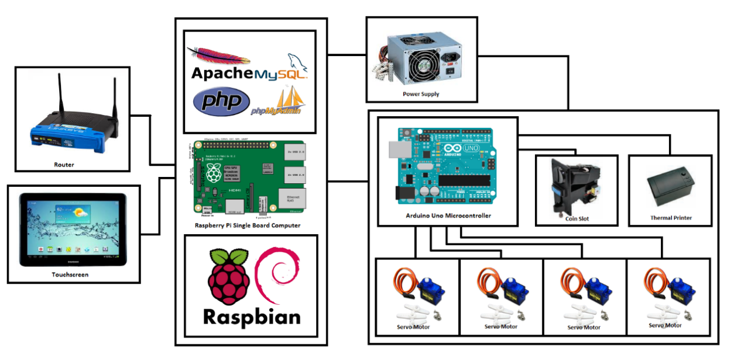

*Figure 3.3.1 Project Architecture*

The figure 3.3.1 shows the architecture of the system. It is uses a Raspberry Pi, a single board computer as its main processor and an Arduino, a microcontroller as its main controller.

3.4DESIGN PROJECT INSTALLATION PROCEDURE

3.4.1 Hardware Installation

**Step 1**: Press button and wait for the led to blink. Insert twenty one peso coin to configure the coin slot to accept one peso coin. The led will blink fast and press the button to configure the second coin. Insert twenty one five peso coin to configure the coin slot to accept five peso coin. The led will blink fast and press the button to configure the last coin. Insert twenty ten peso coin to configure the coin slot to accept ten peso coin. The coin slot is now configured to accept one peso, two peso, and ten peso coin.

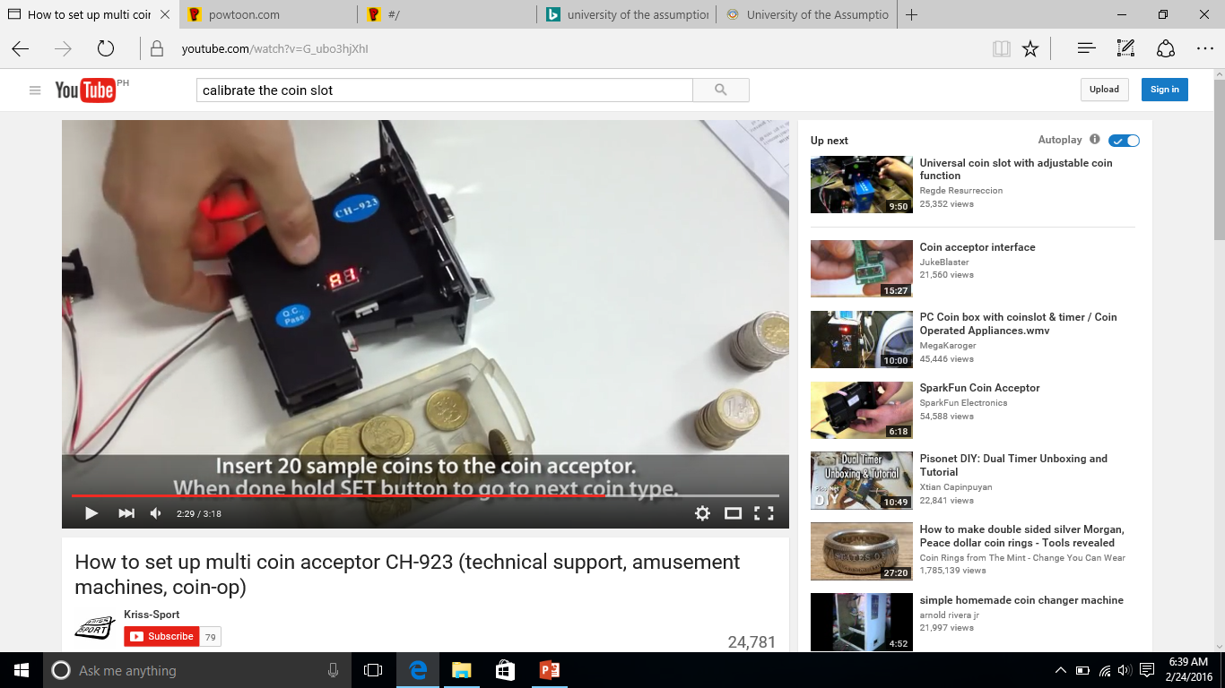

*Figure 3.4.1.1 Configuring the Coin Slot*

**Step 2:** Connect the Raspberry Pi and Arduino through USB cable as shown in figure 3.4.1.2

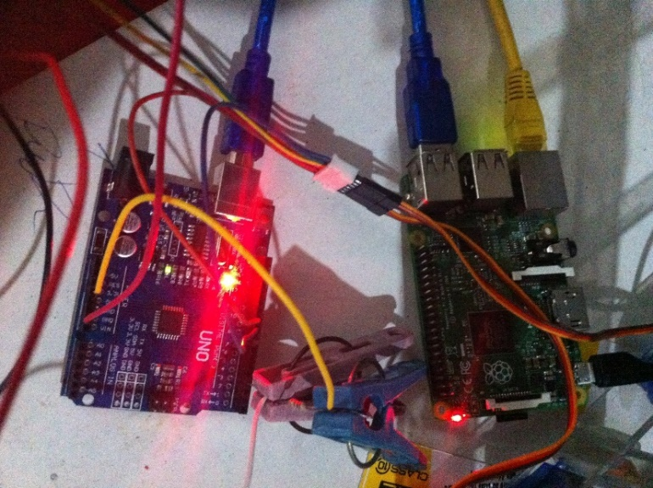

*Figure 3.4.1.2 Connecting Raspberry Pi and Arduino*

**Step 3:** Install the dispenser and attach the wires on pin 9, 10, 11 and 12 on the Arduino as shown in figure 3.4.1.3. Supply the servo motors with 5V power.

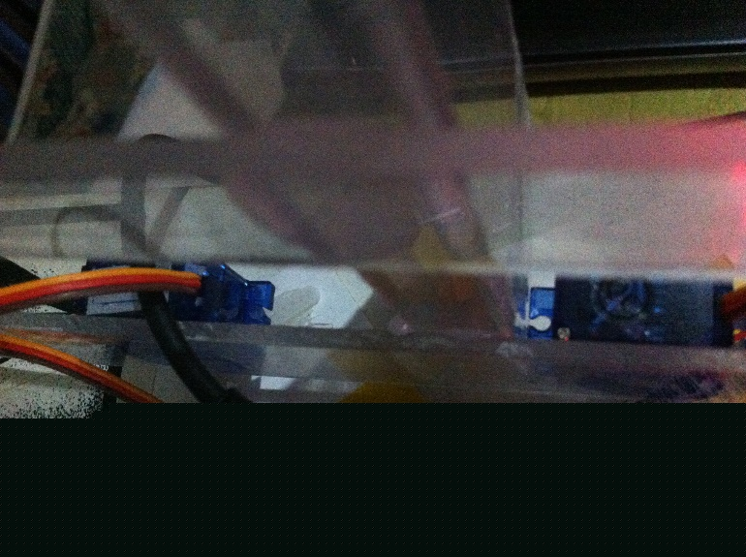

*Figure 3.4.1.3 Installing Dispenser*

**Step 4:** Install the coin slot and attach the coin wire on pin 3 on the Arduino. Supply the module with 12V power and add a 10K ohms pull-up resistor on pin 3 and 5V as shown in figure 3.4.1.4.

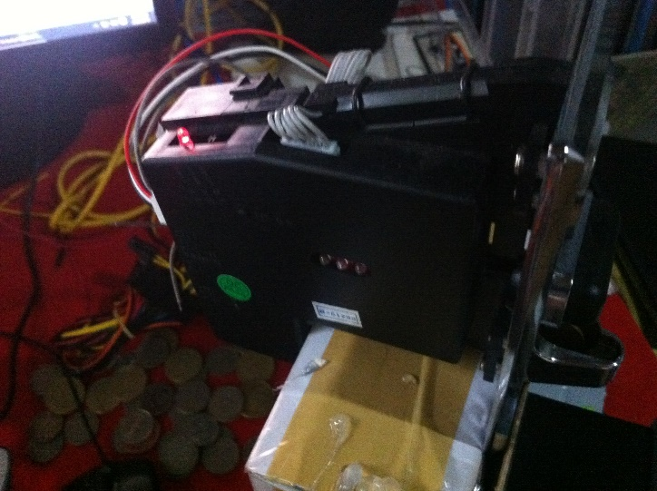

*Figure 3.4.1.4 Installing Coin Slot*

**Step 5:** Configure the thermal printer to TTL mode. Install the thermal printer and attach the RX and TX pin on the Arduino. Supply the module with 9V power using the LM7809 as shown in the figure 3.4.1.5.

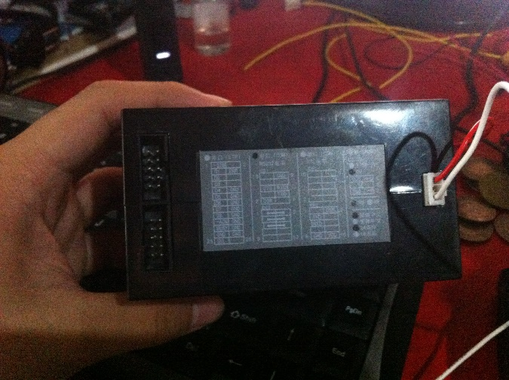

*Figure 3.4.1.5 Configuring and Installing Thermal Printer*

**Step 6:** Configure the router and connect the Raspberry Pi to the router as show in the figure 3.4.1.6.

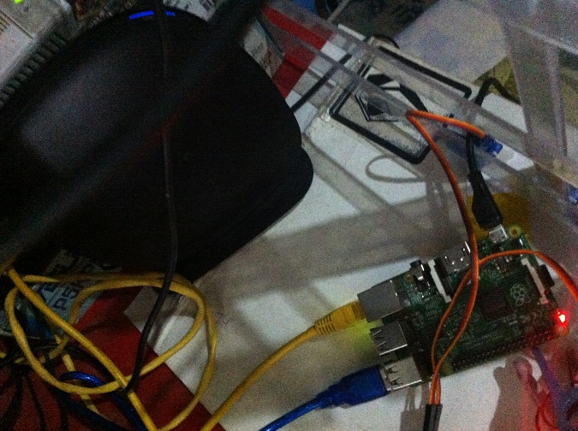

*Figure 3.4.1.6 Configuring and Installing Thermal Printer*

**Step 7:** Install the cooling fan on the vending machine and connect them to 5V power supply as show in the figure 3.4.1.7.

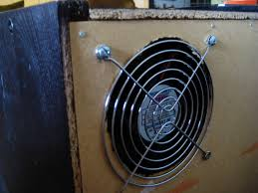

*Figure 3.4.1.7 Installing Cooling Fan*

3.4.2 Software Installation

**Step 1:** Installing the operating system. Installing the operating system requires an image file of the operating system and Win32DisImager to write the image file into a micro SD card. Select the Raspbian image file and the drive where the operating system will be installed then begin the writing process.

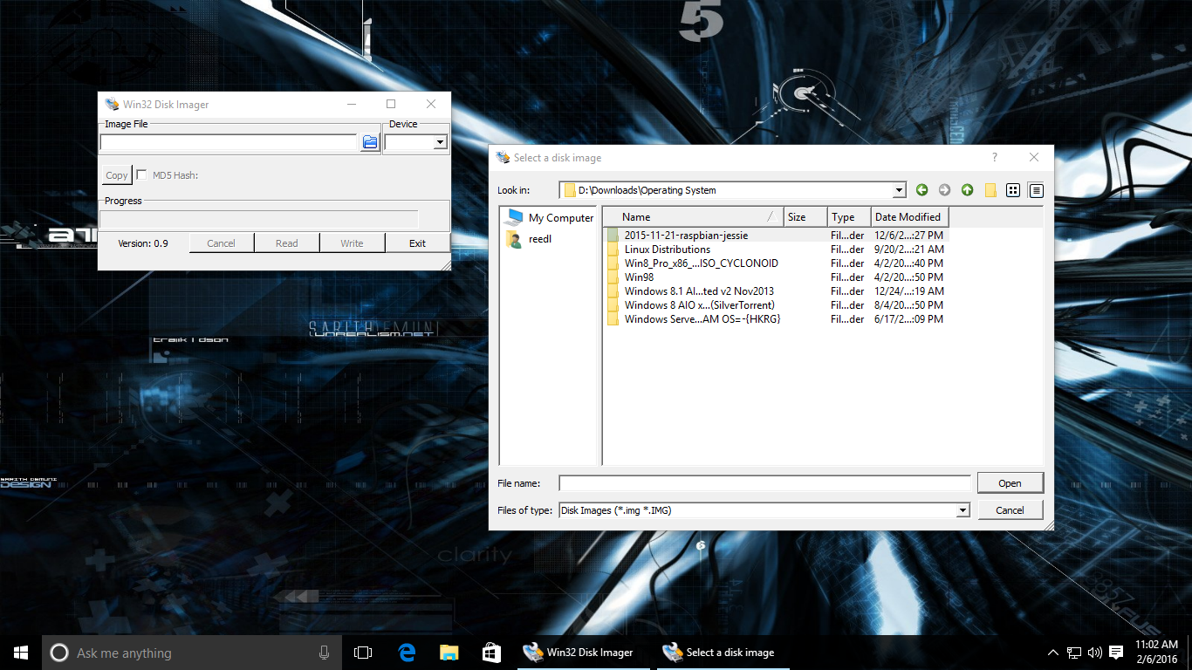

*Figure 3.4.2.1 Formatting and Installing Operating System*

**Step 2:** After installing the operating system, LAMP must be installed to the system. Install apache2 php5 libapache2-mod-php5. Install mysql-server mysql-client php5-mysql. Install and configure phpmyadmin. After installation of the required software, the system is now ready for development.

1. Remotely access the Raspberry Pi using SSH. In windows environment, download putty, a SSH client.
2. Install Apache2 and PHP5: sudo apt-get install apache2 php5 libapache2-mod-php5
3. Install MySQL: sudo apt-get install mysql-server mysql-client php5-mysql
4. Install PhpMyAdmin: sudo apt-get install phpmyadmin
5. Configure PhpMyAdmin: echo Include /etc/phpmyadmin/apache.conf >> /etc/apache2/apache2.conf

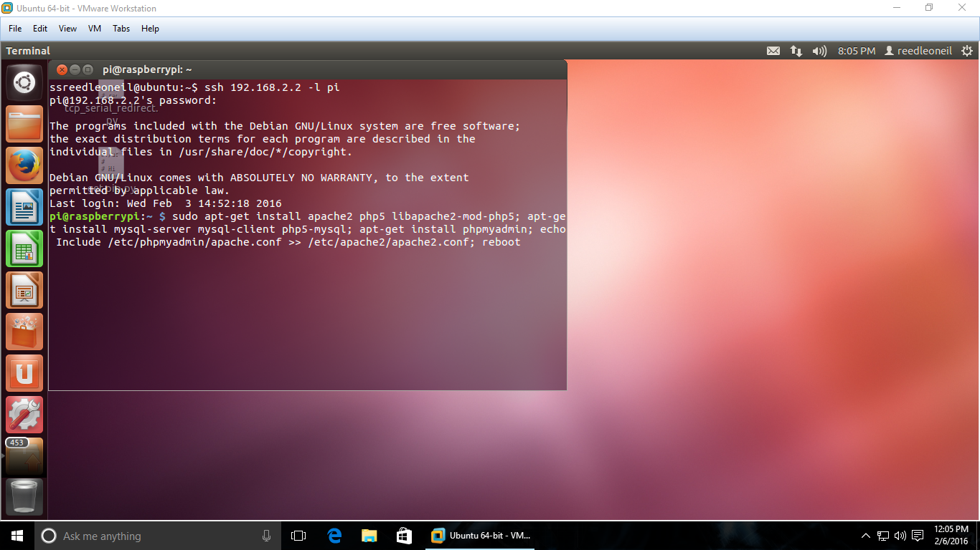

*Figure 3.4.2.2 Installing LAMP in Ubuntu*

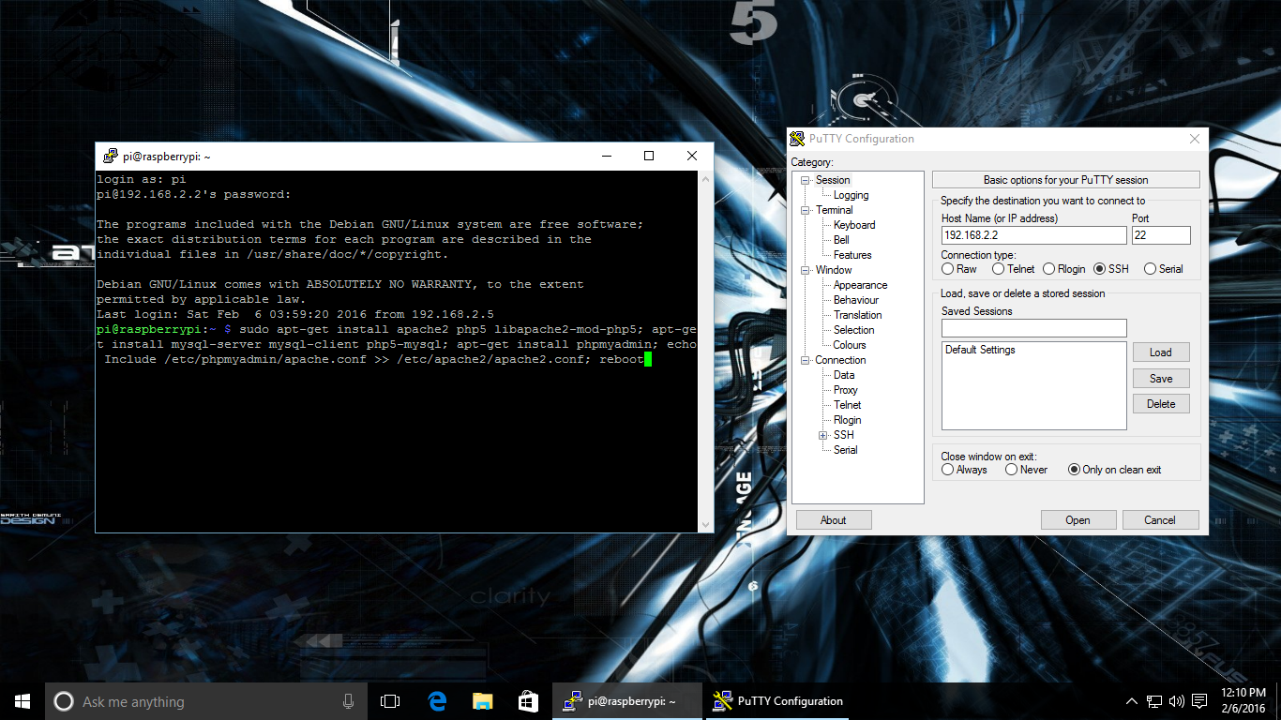

*Figure 3.4.2.3 Installing LAMP in Windows using putty*

3.4.3 Firmware Installation

Installation of the firmware requires the Arduino IDE. The firmware will provide control to the modules of the design project. It also provides the instructions for the Arduino and the Raspberry Pi to communicate.

1. Connect your Arduino using the USB cable.
2. Choose Tools>Board> to find your board in the Arduino menu.
3. Choose Tools>Port> and select the port of the Arduino board.
4. Upload the firmware.

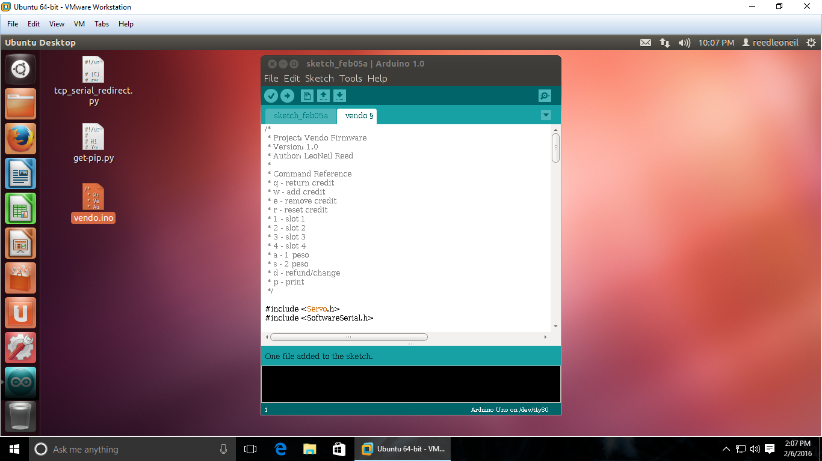

*Figure 3.4.3.1 Installing Firmware in Ubuntu*

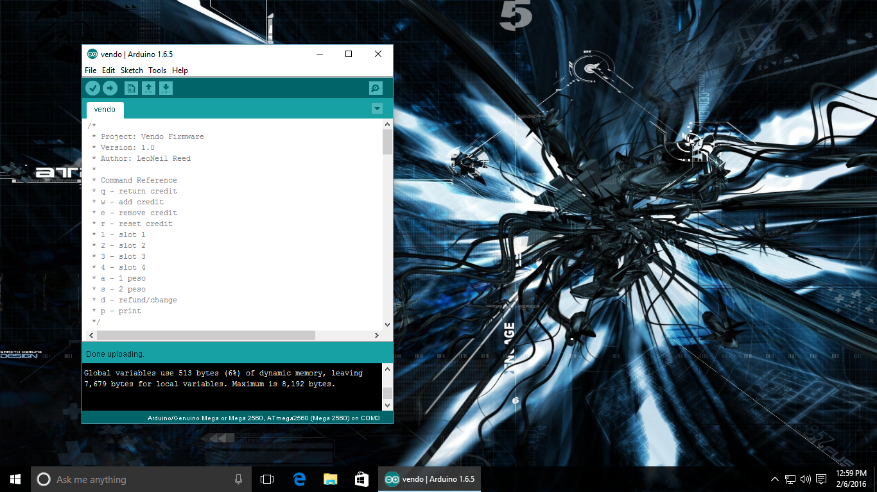

*Figure 3.4.3.2 Installing Firmware in Windows*

3.5 DESIGN PROJECT OPERATION PROCEDURE

The operation procedure for the user, setting up and configuring of the design project will be discussed here.

User Operation:

1. Choose the desired product.
2. Tap more info to view more information about the product.
3. Insert coins.
4. Tap buy to complete the transaction.

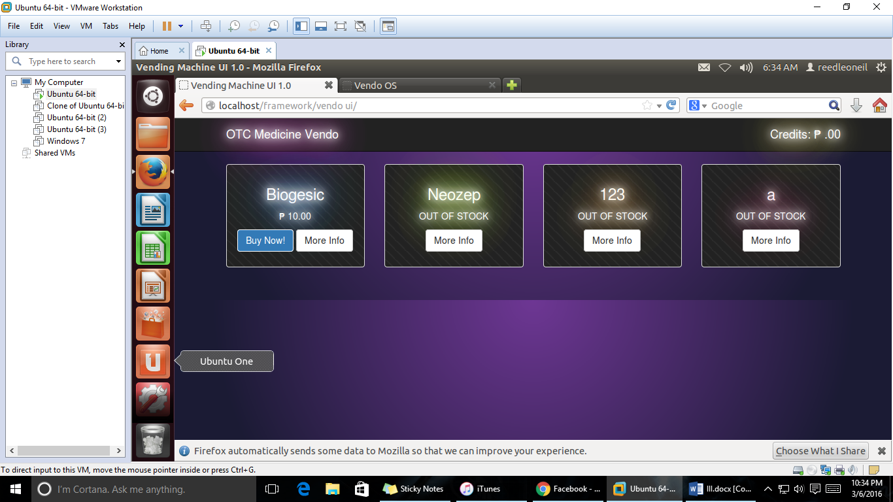

*Figure 3.5.1 User Operation*

Updating Price of the Products:

1. Access the web application.
2. Navigate in the product page.
3. Set price.
4. Click save.

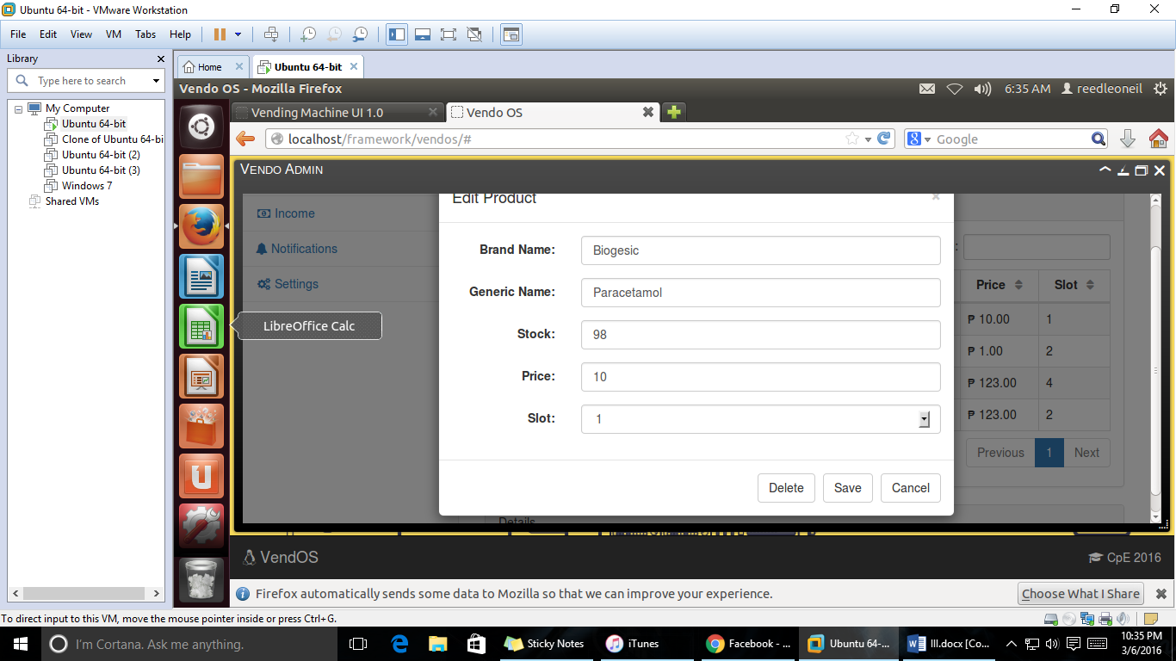

*Figure 3.5.2 Updating Product Price*

Real-time Monitoring:

1. Access the web application.
2. Navigate to the dashboard menu.
3. Monitor stocks, sales, transactions, income and notifications.

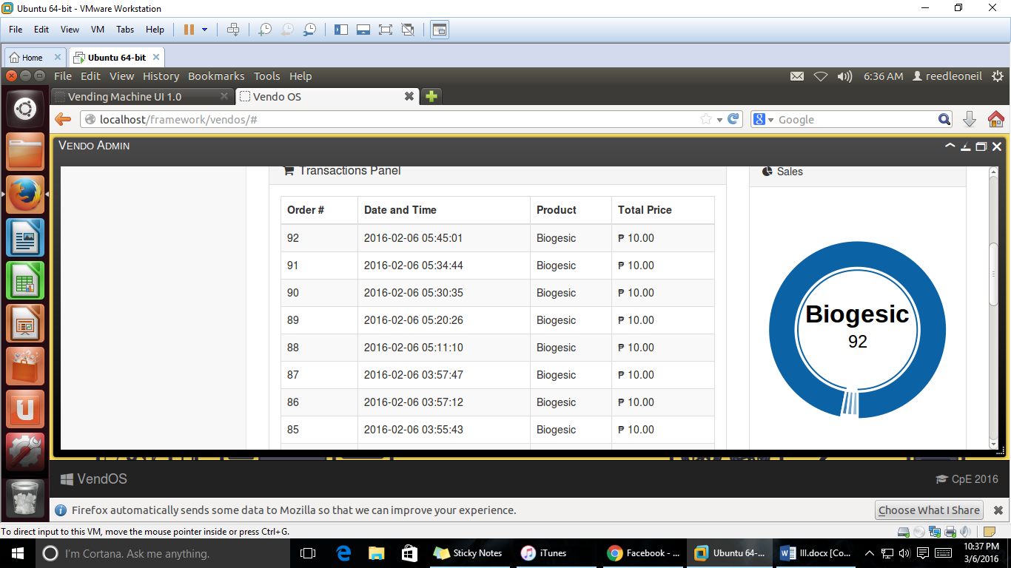

*Figure 3.5.3 Real Time Monitoring*

Configuring Settings:

1. Configuring Advertisement Settings
   1. Access the web application.
   2. Navigate to Settings Menu
   3. Select advertisement setting.
      1. Video – Play a video advertisement.
      2. Social Media Feed – Display social media feed.
   4. Restart the user interface to take effect.
2. Configuring Info Settings
   1. Access the web application.
   2. Navigate to Settings Menu
   3. Select more_info setting.
      1. Info – Display information in text.
      2. Video – Play a video.
   4. Restart the user interface to take effect.
3. Configuring Stocks Critical Level Settings
   1. Access the web application.
   2. Navigate to Settings Menu
   3. Select stocks_critical_level setting.
   4. Set the level.

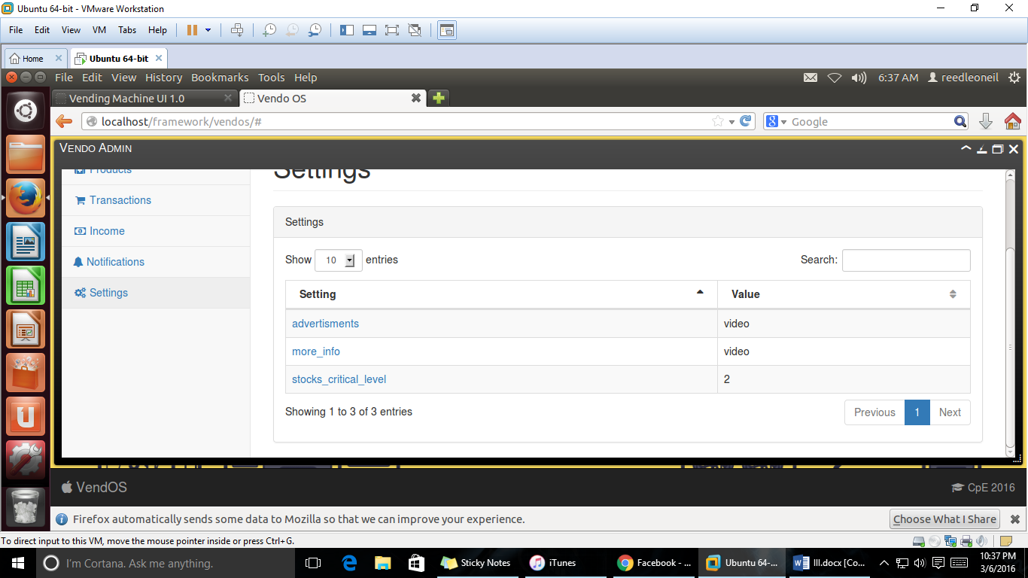

*Figure 3.5.4 Configuring Settings*

Adding Stock:

1. Wait for notification through SMS or access the web application to monitor the stocks for each item.
2. Open the case and refill the dispenser.
3. Update the stocks in the database.

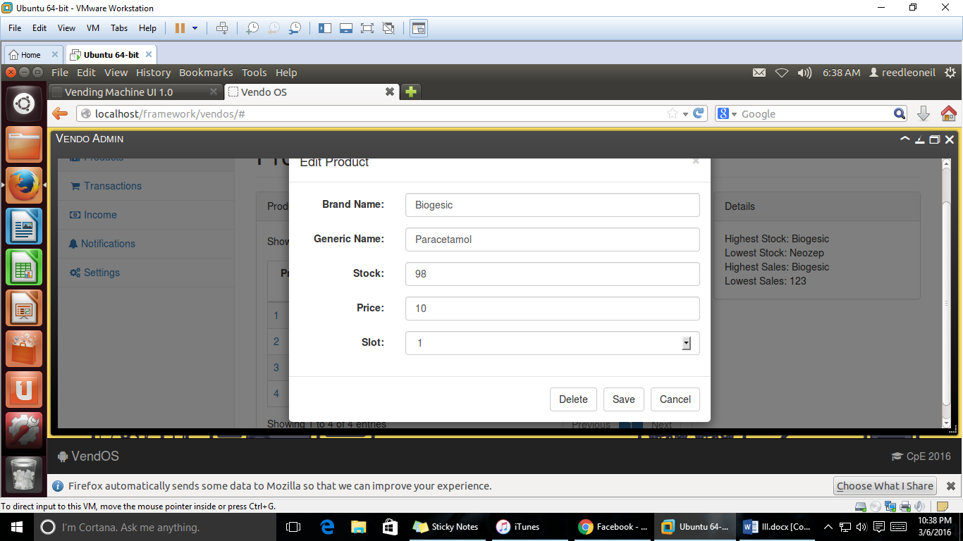

*Figure 3.5.5 Adding Stock*

3.6 DESIGN PROJECT EVALUATION

This section discusses how the design project was evaluated economically, technically and operationally.

3.6.1 Economic Feasibility

The design project cost cheaper than the vending machines available in the market. With its advertising capabilities, it has an advantage of increasing sales and earning extra income for advertising a product.

3.6.2 Operation Feasibility

The design project operates on 220VAC. The design project send a SMS notification when the stock are low, which lessen if not eliminated, the unavailability of the products. The monitoring of sales and changing of product prices in real-time can be accessed through the web application.

3.6.3 Technical Feasibility

The design of the hardware architecture of the developed system is flexible which make the modules vary depending on the availability and cost for each module. The developed system uses free and open source software and libraries for the development of the software.